**TABLE OF CONTENTS**

**1.Introduction**

1.1 Introduction and Objective

1.2 Project Scope

1.3 Deliverables

1.4 why we use c programming

**2. software and hardware specification**

**3. About Grading system**

**4. project core description**

**5. Output**

**6.System development environment**

**7.CONCLUSION**

1.INTRODUCTION

* 1. **INTRODUCTION & OBJECTIVE**

The full form of **CGPA** is Cumulative Grade Point Average.

_ To **calculate** your grade point average, first multiply the number of credits each class is worth by the point value for the letter grade that you earned in that class. Next, total the grade points of **all** of your classes for that **semester** and divide it by the number of credit hours that you attempted.

**1.2**. **Project Scope**:

The scope of the project is to calculate CGPA easily and it is efficient for student. Whom want to calculate his CGPA just input his number then this program automatically calculates his CGPA or GPA and show him.

**1.3 Project Deliverables**

_ We can store the employee’s personal details for internal accessibility.

_ We can post the program details on intranet and we can also prepare the program timetable.

**Why we use C:**

C was initially used for system development work, particularly the programs that make-up the operating system. C was adopted as a system development language because it produces code that runs nearly as fast as the code written in assembly language. Some examples of the use of C:

– Operating Systems

– Language Compilers

– Assemblers

– Text Editors

– Print Spoolers

– Network Drivers

– Modern Programs

– Databases

– Language Interpreters

– Utilities

**2.SOFTWARE AND HARDWARE SPECIFICATIONS**

**HARDWARE SPECIFICATION –MINIMUM REQUIREMENTS**

_ Pentium III processor

_ 128 MB Ram

_ Hard disk 40 GB

_ Microsoft Compatible 101 or more Key Board

**SOFTWARE SPECIFICATION**

_ JDK 1.5 Enterprise Edition (J2EE)

_ Apache Tomcat

_ NET Beans 7.1.2

_ JDBC/ODBC drivers installed.

_ Functional Java enabled browser.

_ Data Base (Oracle 10g ).

_ Operating System (Windows).

**3. About Grading system:**

|  |  |  |  |
| --- | --- | --- | --- |
| **Numerical Grade** | **Letter Grade** | | **Grade point** |
| 80% and above | A+ | A Plus | 4.00 |
| 75 % to less than 80 % | A | A Regular | 3.75 |
| 70 % to less than 75 % | A- | A Minus | 3.50 |
| 65 % to less than 70 % | B+ | B Plus | 3.25 |
| 60 % to less than 65 % | B | B Regular | 3.00 |
| 55 % to less than 60 % | B- | B Minus | 2.75 |
| 50 % to less than 55 % | C+ | C Plus | 2.50 |
| 45 % to less than 50 % | C | C Regular | 2.25 |
| 40 % to less than 45 % | D |  | 2.00 |
| less than 40 % | F |  | 0.00 |

**4.Project core description:**

**Computation of Grade Point Average(GPA):**

**Grade Point averag(GPA)** = ∑ G x C / ∑ G

G = Grade point C = Credit hour

Suppose a student has complete 4 courses in a semester and obtained the following grade:

|  |  |  |  |  |
| --- | --- | --- | --- | --- |
| Course | Grade earned | Grade point(G) | Credit hour(C) | G x C |
| CSE 121 | A | 3.75 | 3 | 11.25 |
| CSE 122 | A | 3.75 | 1.5 | 5.625 |
| MAT 121 | B+ | 3.25 | 3 | 9.75 |
| CSE 103 | A+ | 4 | 3 | 12 |
|  |  |  | Total= 10.5 | 38.625 |

GPA= ∑ G x C / ∑ C = 38.625 / 10.5 = 3.67 That is GPA = A-

First of all we use many feature of c programming language like Array, conditional statement, switch case , mathematical operation and so on to complete this project. At first when user run this program they can chose one from four option that we include in this project using switch case.

1 for GPA calculate

1. for CGPA calculate
2. for Method that we use
3. for Exit.

When user press 1 then program go to cgpa calculate function. Then another choosing option for user which semester gpa he/she want to calculate . after input the number of semester program automatically show those semester subject and credit. After that user can input his achieved number of those subject and then he will see his GPA within a second.

Like this other function will be called when user press 2,3 or 4 and then those function do their job and will show then result. Below I have given some sample output………….

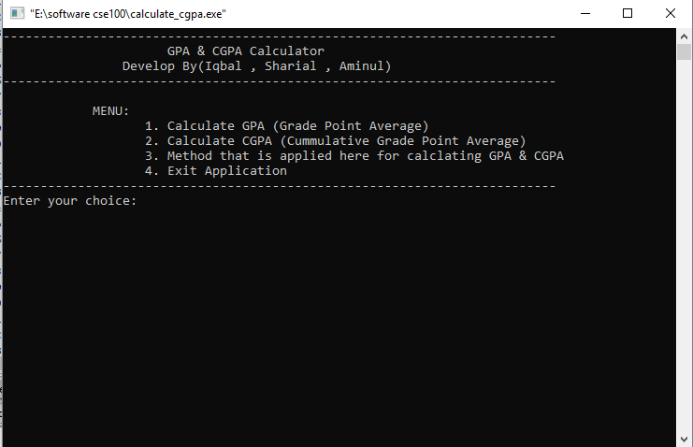

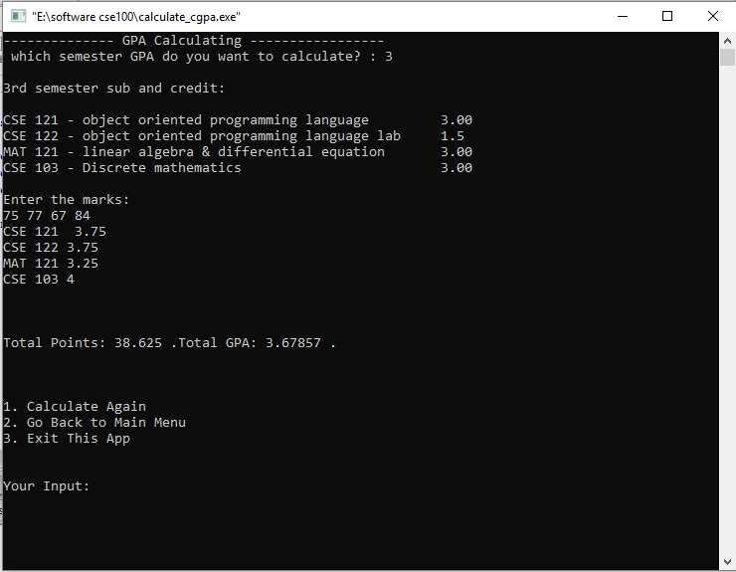

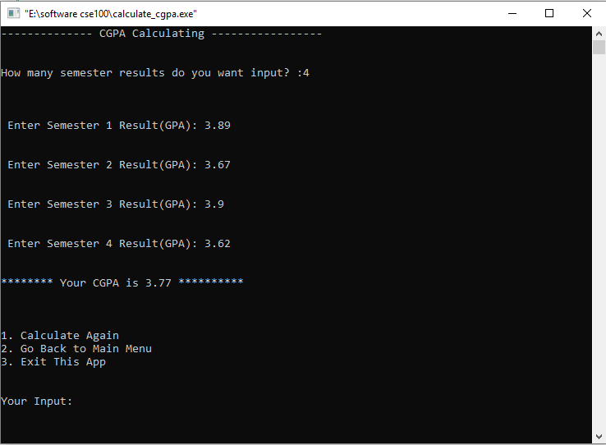

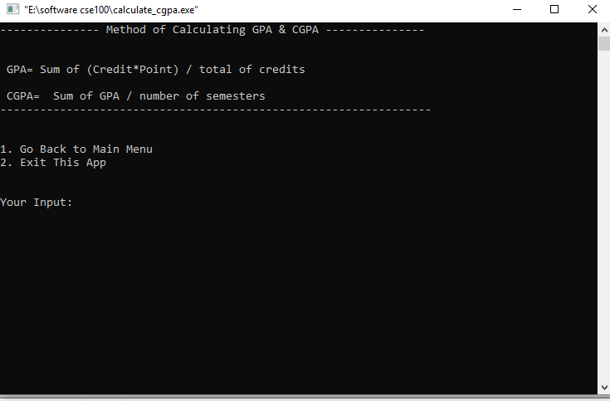

**6.SYSTEM DEVELOPMENT ENVIRONMENT**

**6.1 About c**

C is a general-purpose, high-level language that was originally developed by Dennis M. Ritchie to develop the UNIX operating system at Bell Labs. C was originally first implemented on the DEC PDP-11 computer in 1972.

The UNIX [operating system](https://en.wikipedia.org/wiki/Operating_system), the C compiler, and essentially all [UNIX](https://tekslate.com/tutorials/unixlinux/) application programs have been written in C. [C](https://tekslate.com/history-c-language/) has now become a widely used professional language for various reasons:

– Easy to learn

– Structured language

– It produces efficient programs

– It can handle low-level activities

– It can be compiled on a variety of computer platform

**7.PROJECT TESTING**

**7.1 SOFTWARE TESTING TECHNIQUES:**

Software testing is a critical element of software quality assurance and represents

the ultimate review of specification, designing and coding.

**6.3 TESTING OBJECTIVES:**

1. Testing is process of executing a program with the intent of finding an error.

2. A good test case design is one that has a probability of finding an as yet undiscovered

error.

3. A successful test is one that uncovers an as yet undiscovered error.

These above objectives imply a dramatic change in view port.

Testing cannot show the absence of defects, it can only show that software errors

are present.

**7.CONCLUSION**

The project titled as **GPA and CGPA Calculate** was deeply studied and

analyzed to design the code and implement. It was done under the guidance of the

experienced project guide. All the current requirements and possibilities have been taken

care during the project time.

GPA calculating system is used for daily operations in any university to

Calculate their student GPA and student can also easily calculate their GPA ….